CLIENT Macmillan Cancer Support
CAMPAIGN Coffee Morning 2006

CASE STUDY

BACKGROUND
Macmillan Cancer Support’s national fundraising event is the World’s Biggest Coffee Morning; people all around the country are asked to hold coffee mornings and give the proceeds to Macmillan to provide vital funding for their support for those with cancer and their families.

Issues to overcome
- How to reach a target audience that aren’t already supporters of Macmillan. How can we get onto their radar?
- People think that it is hard work. How can we convince them that it isn’t?
- How to ensure that people who register for the event then go on to subsequently hold their coffee morning, and send in their money?
- The name ‘coffee morning’ and its associations – how can we break down these perceptions of the event?
- The event, being 15 years old, is getting tired with the press – how can we rejuvenate it?

OBJECTIVES
To motivate people to sign up to host a coffee morning for Macmillan and give them the contact details to ensure that they can do this in the way most convenient for them.

To decrease the non-donating rate of registered hosts

STRATEGY.
2006 saw a strong focus on two issues – increasing relevance amongst the target audience and ensuring that the event had a bigger, more ‘national’ feel.

Through strong profiling of the current audience and hosts, pen portraits were developed of three types of women that activity should focus on. This was then applied across the media planning and buying of direct mail, national press advertising, online and radio advertising.

Proposition
Get together for a coffee and help people living with cancer.

Media choice
A partnership with Classic FM helped give the campaign a more national feel, with presenters fully endorsing the event at every opportunity. Through a competition for a classical artist to appear at one of the listeners’ coffee mornings, the incentive to hold the coffee morning following registration was increased, and a competition for people who sent in their money by a certain date encouraged people to send their money back in promptly.

Several regions were selected as ‘hotspots’ where discreet activities were undertaken to test new communication channels with the aim to roll out successful elements nationwide in subsequent years.

CREATIVE AND EVENT EXECUTION
Creative was designed to have a more ‘lifestyle’ appeal, showing people that a coffee morning is fun and something that is really simple to do. Strong consideration was given not only to the visual but to the wording. Rather than ‘Host a coffee morning’ the focus was on ‘get together with friends’ – emphasising the sociability and ease of the coffee morning.

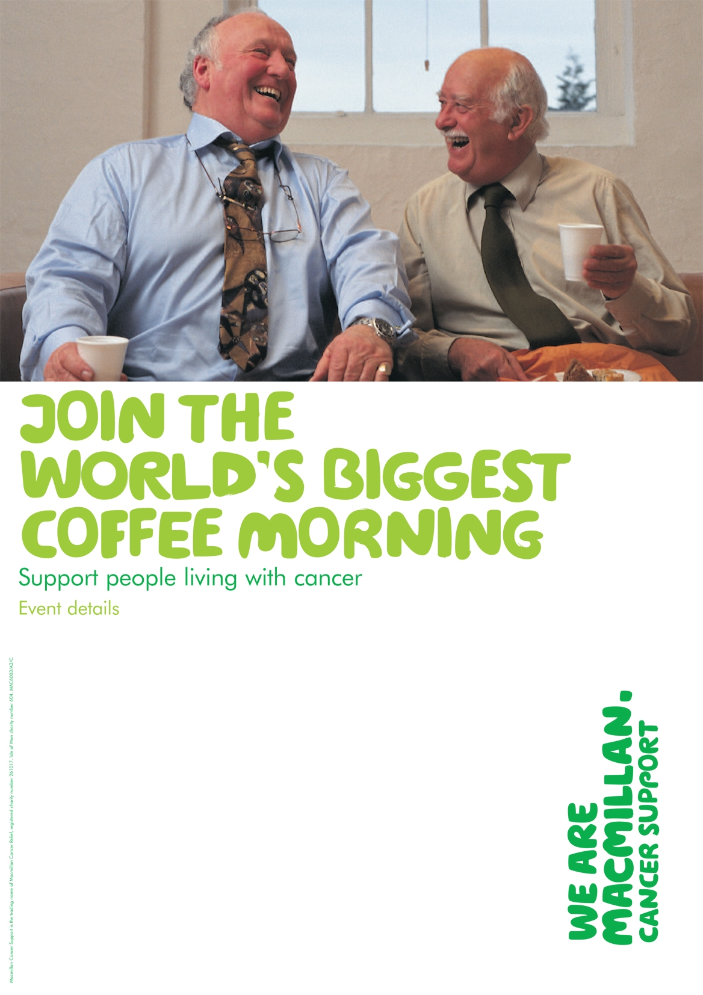
Recruitment poster In-pack poster

Different images were used for different audiences e.g. people holding their event at home, at work or within the community.

A combination of silhouettes and photography was used depending on the objective and functionality of the piece.

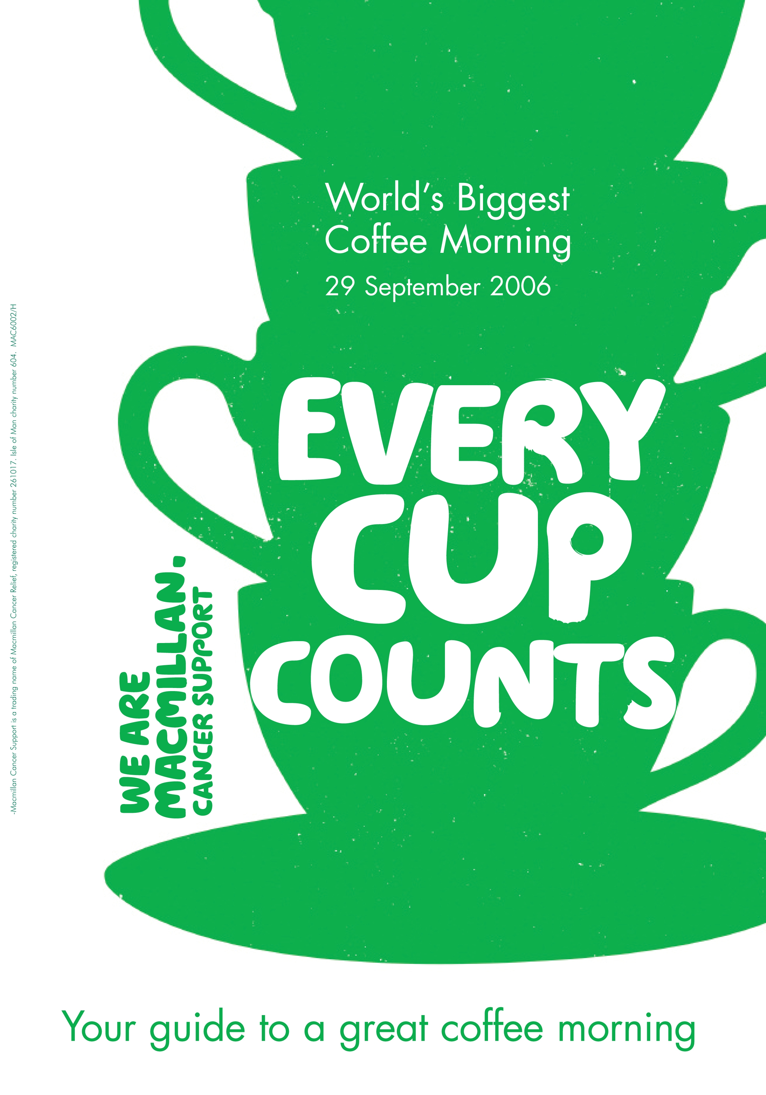

Front cover of in-pack guidelines

OUTCOME AND EVALUATION
World’s Biggest Coffee Morning 2006 raised an amazing £6.75million. The number of coffee mornings across the country exceeded 50,000 with over 2 million people involved overall.

Registrations increased by 2%
Income increased by 7.5%

These figures show that the average donation / donation rate also increased.

The number of registrations directly attributable to Ideas’ campaign was 35,000. This includes all registrations through direct mail carried out by Head Office, national advertising, hotspot activity and radio.

LENGTH OF RELATIONSHIP
Having worked on the event for 8 years, we have taken it from raising £1.4million per annum to £6.75million.

BUDGET
£1,084,600

ROI = 1:6.2

