CASE STUDIES

Client: Wood Window Alliance

Campaign date: July 2007 onwards

BACKGROUND

The Wood Window Alliance brings together 40 of the key companies within the window industry to produce a joint UK marketing initiative backed by quality guarantees. Backed by wood for good and managed by British Woodworking Federation, the three year campaign was launched in July 2007.

THE CHALLENGE

To fight back against the PVC-U windows industry, which is now beginning to challenge wood windows on sustainability as well as thermal performance, durability and maintenance.

STRATEGY
The first stage was to work with the Building Research Establishment to establish quantified sustainability claims expressed as Life Cycle Assessment ratings for members’ windows.

The second stage was to agree a minimum standards threshold for membership. This allowed us to create a quality brandmark with real meaning, as it was backed up by a series of specific performance and sustainability criteria.

The campaign was launched with a co-ordinated PR and advertising programme to establish the quality brandmark among specifiers, contractors and clients.

Other materials produced by the agency included brand guidelines, frame and pane window labels, a members marketing toolkit, a website, with searchable member database, an exhibition stand, and trade and consumer literature.

CREATIVE WORK

Trade leaflet - This leaflet has been designed as an introduction to the Wood Window Alliance for the trade, explaining what it means to be a member and spelling out the benefits of specifying windows bearing the quality brandmark.

Consumer brochure - The consumer brochure has been designed for members who sell to consumers either directly, or indirectly, through developers or Housing Associations.

Advertising - The campaign initially targets three key audiences:
- The public sector - important customers for wood windows, looking for sustainability and under pressure from the plastics industry
- Architects, specifiers, contractors, developers - looking for performance as much as sustainability
- The timber industry - who we want to join the campaign

Launch ad (public sector) Launch ad (specifiers & contractors)

Follow-up ad (industry) Follow-up ad (public sector)

Follow-up ad (specifiers & contractors.)

Website

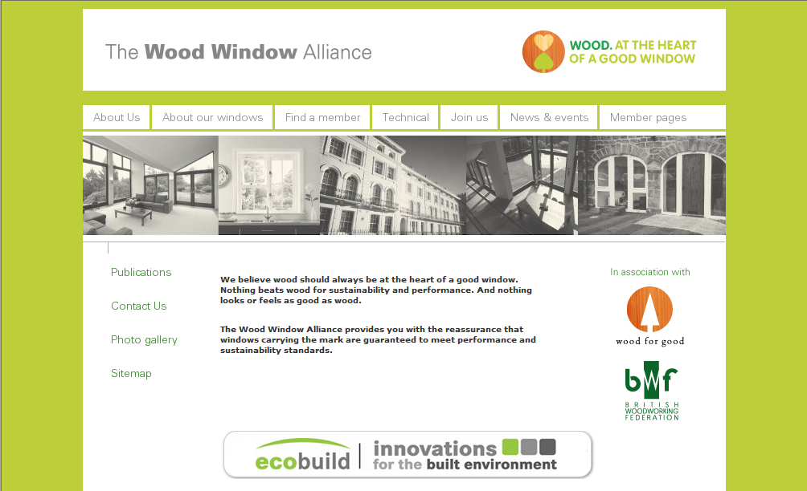

RESULTS
Campaign results will be monitored annually by member turnover.

