CLIENT Forum for the Future
CAMPAIGN

CASE STUDY

BACKGROUND
Set up by Jonathon Porrit and Sara Parkin in 1996, Forum for the Future is the UK’s leading sustainability charity. In 2006, Jonathan stood down as Chief Executive and Peter Madden was appointed to take Forum forward. The Strategic Review that followed simplified the organisation and recognized the need to place greater emphasis on practical projects – doing, rather than discussing. Ideas had to bring the brand in line with the new strategic direction.

STRATEGY
As the first stage, we worked with the client to get everyone to agree what the refreshed brand stood for, giving them a clear and motivating brand architecture:

Vision: Business and communities thriving in a future that’s environmentally sustainable and socially just.

Mission: To find practical ways that private and public organisations can deliver a sustainable future.

Values: Effectiveness, advocacy, integrity, collaboration, optimism and practicality.

As the project developed it became increasingly clear that the familiar Forum for the Future logo would need major surgery to fit in with the new strategy. It was all about the old brand – nice, gentle, painless and unassertive. We needed to symbolize the change without losing brand recognition.

Every stage of thinking and creative development was worked on together with the brand team, sold through to the management team and debated with all team members at regular ‘brown bag lunches’.

CREATIVE
The new logo – the result of several collaborative stages with the client team – is still instantly recognizable, but the colour makes a dramatic statement of change. The icon has a businesslike sense of solidity; the logotype is bolder and more contemporary. It has strength and practicality.

Although the client was initially uncomfortable about the idea of using a strapline, we felt it was an important part of fulfilling the new strategy. We devised the line ‘action for a sustainable world’. From ‘talking shop’ to ‘taking action’, the new strapline is an integral part of the new design. It acts as an antidote to the name, it explains what Forum for the Future does, and how it does it: with ambition, advocacy and optimism.

A master illustration was commissioned from which elements can be used to add character; distinctive photography, and writing guidance, all brought together in a digital Brand Guidelines manual.

The brand was launched at an all-team away day and the project went live on a special celebration day with updated websites, screen savers, freshly decorated offices, cakes, flowers and banners.

‘…a big thanks to you and the team for the effort you have put into the whole process of refreshing our brand…all agreed that the internal launch had gone really well, and we are getting good reactions externally…it is already building morale and confidence in the organisation and will bring a new professionalism to our outputs that will help us achieve our mission.’
Ben Tuxworth, Director of Communications
CREATIVE EXECUTION

OLD LOGO

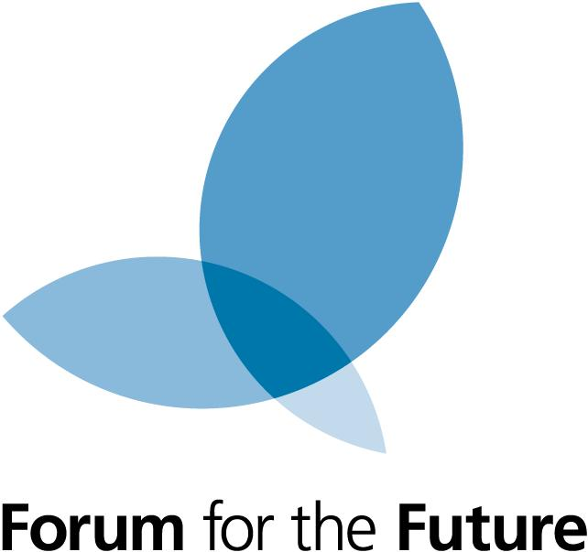

Publications

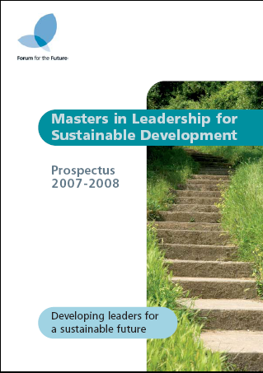

NEW LOGO

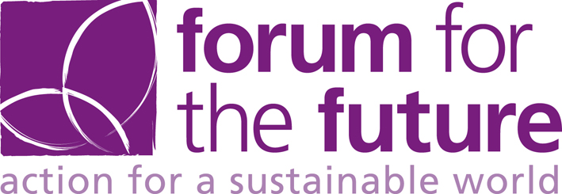

Annual Report

Exhibition Stand

