CASE STUDIES

Client: Compost Association

Campaign date: May 2005

BACKGROUND

Who is the client and what do they do?
How long have you worked with them?

We worked with The Compost Association for three years promoting National Compost Awareness Week.

Historically Compost Awareness Week was a multi-media publicity and education initiative to showcase compost production and demonstrate compost use. It aims to encourage the public and business communities alike to take action to support composting at all scales and to use composts.

Each year in May, members of the composting industry, local authorities and garden centres are encouraged to hold special events to encourage consumers to consider composting their garden and biodegradable household waste. Such events included open-days at large scale composting facilities, the launch of local authority composting initiatives, specialist compost seminars, openings and tours of compost demonstration gardens, and compost roadshows.

THE CHALLENGE

What issues did the client face? What were the objectives? What made that difficult?

The Compost Association is heavily influenced by it’s members, the compost manufacturers, and wrap who were funding part of the campaign. The campaign therefore had to balance the members desire to encourage consumer to purchase compost from garden centres whilst encouraging home composting.

Through research we were made aware that whilst there was a broad understanding amongst the target audience of the benefit of buying compost to put on their garden, there was a lack of knowledge of how to compost, what to compost and why to home compost.

STRATEGY
Key components on the brief – insight/message/tone etc
Include media choice if relevant

The campaign promote composting as an everyday activity in line with WRAP’s recycling campaign, the possibilities are endless. The campaign messaging aimed to balance the objectives worked at three different levels, communicating:

Why you should use compost
Why you should home compost
What you should home compost
How to home compost and ultimately to buy a home composting bin

The campaign consisted of a retail poster used in garden centres throughout the UK and by local authorities at events.
Press ads used in local press and local authority community newslettters
Take on flyers/inserts used at garden centres and distributed by local authorities.
Event stand used as recycling events

CREATIVE WORK
[Insert screen grab / image where possible]

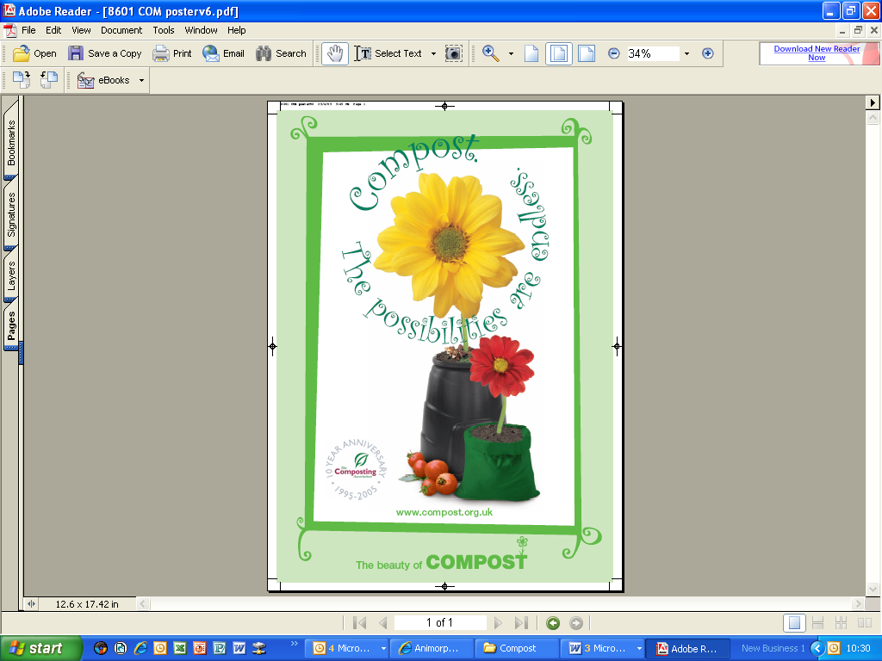

RESULTS
[As detailed as possible please – ROI, client quotes if available etc.]

Well received by

