Charity Event & Family Fun Day

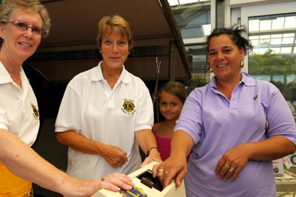
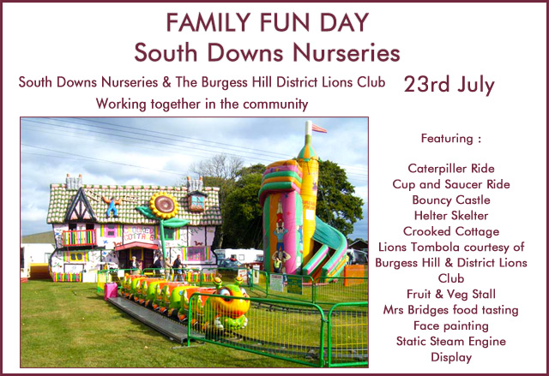

South Downs Nurseries are pleased to announce that we helped raise over £250 with the Burgess Hill District Lions and Champion butcher Gary Knight sold out of his award winning sausages! Gary, the 'Ditchling Sausage', will be returning every Sunday selling his prize sausages and will be attending the Big Charity Car Boot Fair at South Downs Nurseries on Saturday August 13th.

